Biology 171 – Spring 2021
Lab 3: Genomics and Phylogenies
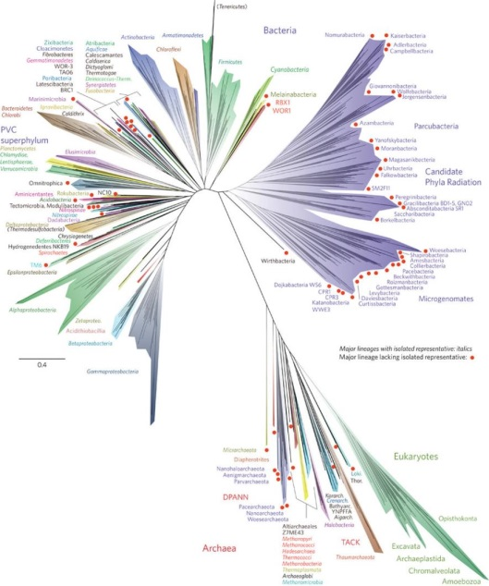
In these classes we are focusing on the Genomics Tree of Life – a phylogenetic family tree of life based on DNA genetic sequence data. In class you have been seeing genetic sequences and phylogenies constructed from the alphabet of life – A, T, G, and C – the four neucleotide bases that encode information for virtually all life on Earth. Where do these data come from? How are these sequences generated? What do they mean?

One of the breath-taking things about the times we are living in is how rapidly the DNA sequencing technologies are changing. Biologists are making stunning new discoveries almost weekly based on genetic sequencies. It is pretty amazing that some of the phylogenetic figures in our 3-year old textbook are already obsolete!!

Here at University of Montana we have a cutting-edge, world class genomics facility. There are many professors, graduate students and undergraduate students who are using these facilities to discover amazing new things about other creatures we share the planet with. In this week’s lab, you will have a virtual tour of the UM Genomics facility. We hope that this gives you a better sense of how the genetic data that you read about and that we discuss in class comes from. We will also explore a little bit about how phylogenetic trees are constructed.

At the end of this lab you should:

- Understand how we get genetic sequences.
- Understand the importance of the enzyme Taq.
- Be able to explain the significance of Thermus aquaticus, a bacteria that was discovered in near-boiling water in hot springs in Yellowstone National Park.
- Be able to describe how and why Taq works in the PCR reaction.
- Have a better appreciation of what a modern genomics lab is like.
- Be able to describe some of the key steps in generating genetic sequences.
- Be able to describe the differences between Sanger Sequencing and Next Generation Sequencing.
- Be able to construct some simple phylogenies from matrices of genetic (or other) traits.

Part 1 – Virtual Tour of the UM Genomics Facilities

In your lab you will get a virtual tour of the Genomics Facilities. To give you an idea of how rapidly the field of genomics is changing here is an amazing example. The first complete sequence of the human genome was completed just 17 years ago. There were many genetics labs all around the world working together on this project, and it took hundreds of scientists 13 years to complete this project. It also cost OVER $3,000,000,000 to sequence the first human genome. With one of the Next Generation Sequencing machines you will see during this lab, it is possible for an undergraduate student to sequence a complete human genome in about 24 hours, at a cost of about $1,000!

You will see a few of the most important machines and steps to get genetic data. But before genetic sequencing starts, researchers must isolate and purify DNA from their organisms of interest. We will not cover that in this lab, but if you are interested in these precursor steps here is a good video to watch (Dr. Eric Green – NO KIDDING – and Dr. Carla Easter, show how to isolate DNA from strawberries: https://youtu.be/hOpu4iN5Bh4)

Here are resources to help with this lab

- Genomes – chapter 12 in the class textbook. Make sure you read up to section that starts “Genome sequences yield several kinds of information.” This is just slightly over 3 pages in the book. Make sure that you study Figures 12.1 and 12.2.
- There are MANY videos online about genetic sequencing! Some are very technical, and cover material beyond the scope of this class, but you should poke around and see what you can find. Here are a few videos that give overviews of Sanger Sequencing and Next Generation Sequencing (NGS)

https://www.thermofisher.com/blog/behindthebench/how-does-sanger-sequencing-work/

Comparison of Sanger Sequencing and NGS
https://www.youtube.com/watch?v=mI0Fo9kaWqo

This is a pretty technical description, but if you are interested it gives a lot of detail. https://www.youtube.com/watch?v=Wpww8bb63zU

From your virtual tour of the genomics facility (and other resources), answer the following questions.

- What does “PCR” stand for?

- What is Thermus aquaticus? What is special and important about it?

- What is Taq? How is it related to PCR?

- Briefly describe what the PCR machine does. What role does Taq play in this?

- What does A stand for? Draw a sketch of the molecule. Sketch it yourself – don’t paste an image from the internet!

- What does T stand for? Draw a sketch of the molecule. Sketch it yourself – don’t paste an image from the internet!

- What does G stand for? Draw a sketch of the molecule. Sketch it yourself – don’t paste an image from the internet!

- What does C stand for? Draw a sketch of the molecule. Sketch it yourself – don’t paste an image from the internet!

- Heidi runs 35 cycles when she does PCR amplification of her DNA samples. If she starts with one copy, how many DNA copies will she have after her 35 cycles?

- Briefly describe in your own words how Sanger Sequencing works.

- The techniques used in Sanger Sequencers is based on technology is almost 50 years old. If the Sanger Sequencer method is so old, why does the UM Genomics lab still have a machine and still use it??

- Briefly describe how the Next Generation Sequencing method works.

- How much faster are the Next Generation Sequencers than the original technology used to sequence the first human genome sequence?

- How much cheaper are the Next Generation Sequencers than the original technology used for the first human genome sequence?

- Imagine that a friend of yours who does not know much about DNA sequencing asks you to explain why it is important. In your own words describe, in a way your friend could understand, some of the important applications of DNA sequencing in a variety of fields.

Part 2 – Constructing phylogenies

Once scientists have genetic sequence data, that next step can be comparing sequences between different samples to see how similar or different they are. This is typically done with PHYLOGENIES. Now that you have a better sense of how biologists generate genetic sequences, let’s work through a couple of simple exercises that will give you a bit more practice constructing phylogenies from matrices of traits.

Resources

- Phylogenies – chapter 14. Read up to (including) 14.2. Those of you taking the class (Biob 170) should have already read this, but be sure to review it.
- There are MANY great videos online about how to make and interpret phylogenies. Here is a good overview of phylogenetic concepts::
- https://www.khanacademy.org/science/ap-biology/natural-selection/phylogeny/a/building-an-evolutionary-tree
- This is a useful video “Creating Phylogenetic Trees” that presents a useful method that will be useful to you for making trees. https://www.youtube.com/watch?v=09eD4A_HxVQ

Warm-up: flexing your phylogenetic muscles.

Here is Table 14.1 from your Hillis textbook:

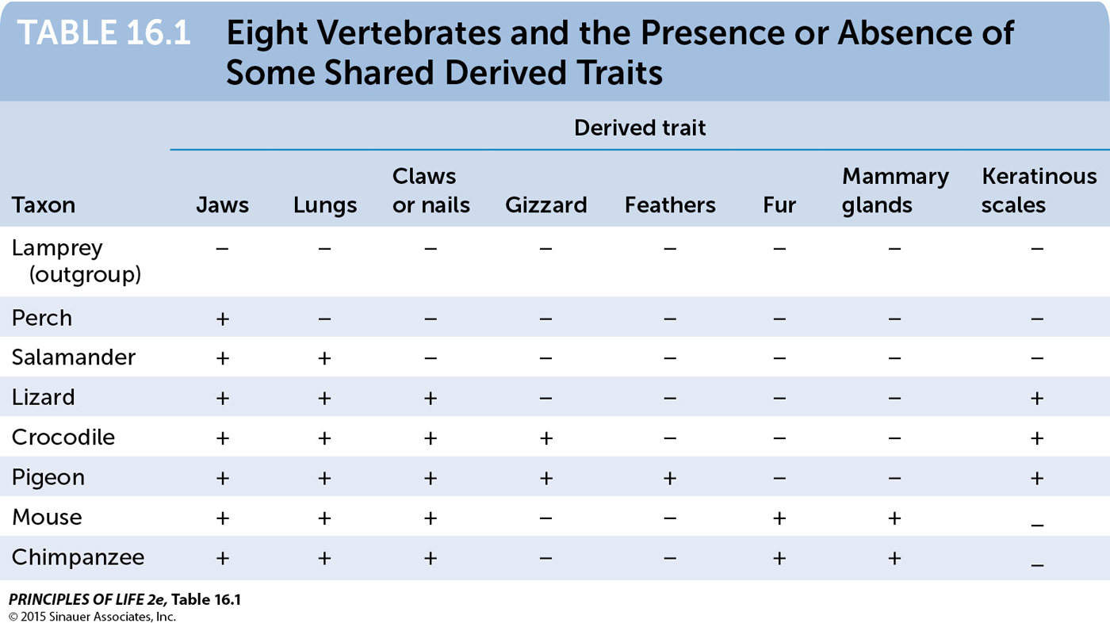
TABLE 14.1

This table summarizes the presence or absence of important traits among some vertebrate groups. In this case, the “characters” used to construct a phylogeny are morphological traits.

- Work through this table to produce a phylogeny based on these traits. Feel free to work with your class mates on this. Produce your own drawing of your phylogeny based on this table.

- What is a shared derived trait?
A shared derived trait is a trait that all members of a clade have that because they all have descended from the same individual who originally mutated to have that trait.

- What is a synapomorphy?
A synapomorphy is a fancy word for shared derived traits.

- What is the synapomorphy that separates the outgroup (lamprey) from all the other vertebrates?
Jaws

- What is the synapomorphy that separates the clade of lizard, bird and crocodile from other vertebrates?
Keratinous scales

- On the phylogeny that you draw, make sure that you indicate all the synapomorphies in the appropriate places.

- What is the function of an outgroup? Why are outgroups important to make a phylogenetic tree? Could the structure of a phylogeny change depending on the particular outgroup that you used?

OK – Now that you are warmed up, on to some genetic data

Your textbook describes an experiment in which T7 viruses were grown for over 1,200 generations (See Figure 14.7). The DNA mutated quickly, and so the genetic sequences of different lineages changed over the course of the experiment. The table below shows the genetic sequences for 5 different viral lineages at the end of the experiment (and an outgroup). The complete analysis for this experiment was based on the sequence of THOUSANDS of nucleotides. For simplicity in this exercise we are just going to look at the sequence for 23 nucleotides. This experiment is described more fully in Figure 14.7 of your textbook. The table below is a simplified version of the table in your book – it contains fewer lineages just to make this exercise a bit easier.

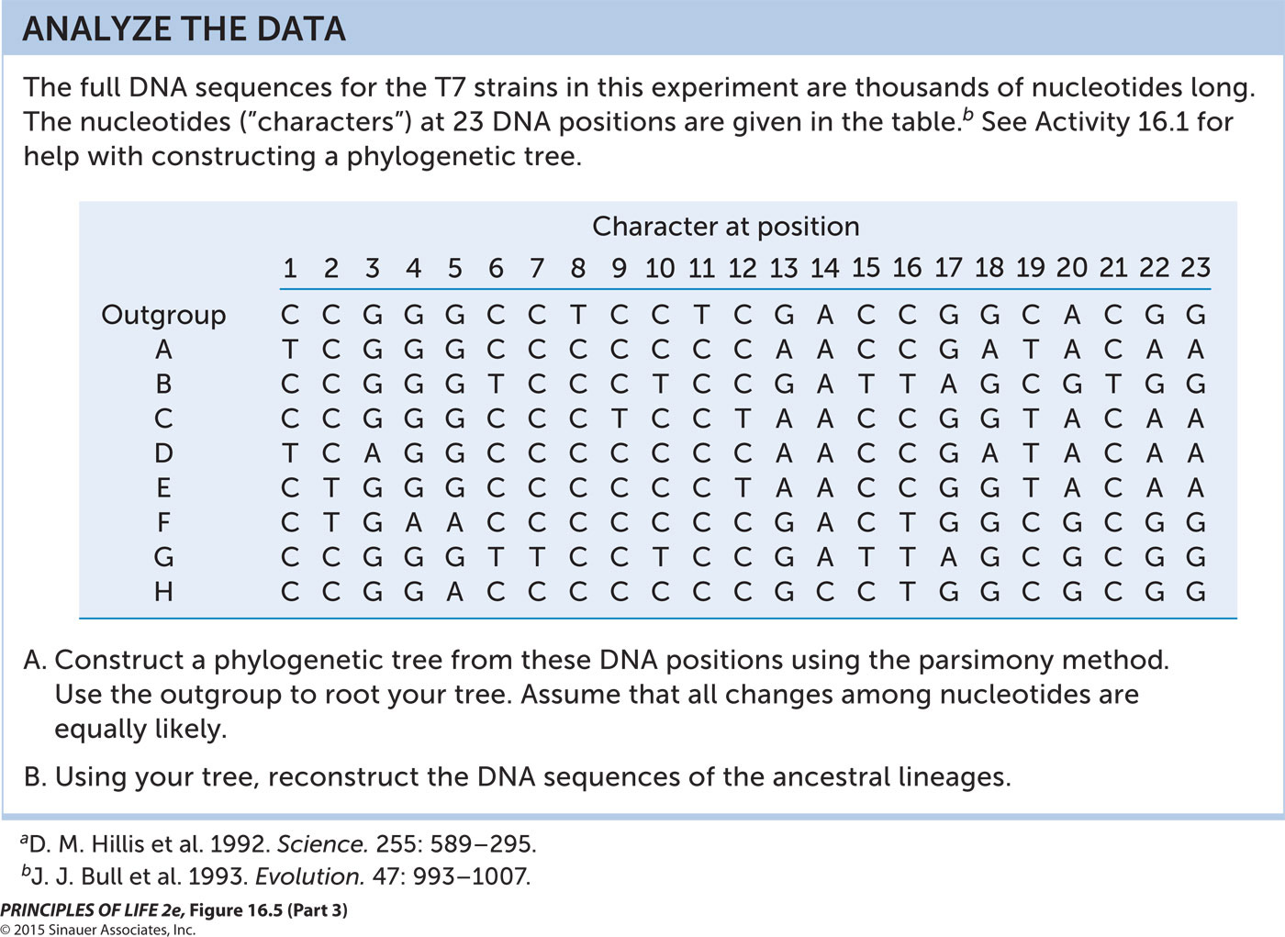

- Use the similarity matrix method to analyze the genetic similarities of the lineages. We will go over this in class, and this video does a good job explaining the method (https://www.youtube.com/watch?v=09eD4A_HxVQ). Show all of your steps! I.e., show all of your matrices in your analysis.

- Draw a phylogenetic tree based on these genetic data. On your tree, show where the mutations in base pair sequences occur along the various branches. Here is a short-hand to use: 5: G → A. This would indicate that at position 5 there was a change from G to A in that branch.

- What is the Principle of Parsimony? How does it apply to constructing phylogenetic trees? Here is a useful link: https://evolution.berkeley.edu/evolibrary/article/0_0_0/evotrees_build_07

- How did you use the Principle of Parsimony to produce your phylogenetic tree of the virus lineages?

